Title: Bike Safety Around MIT

Photos for this section:

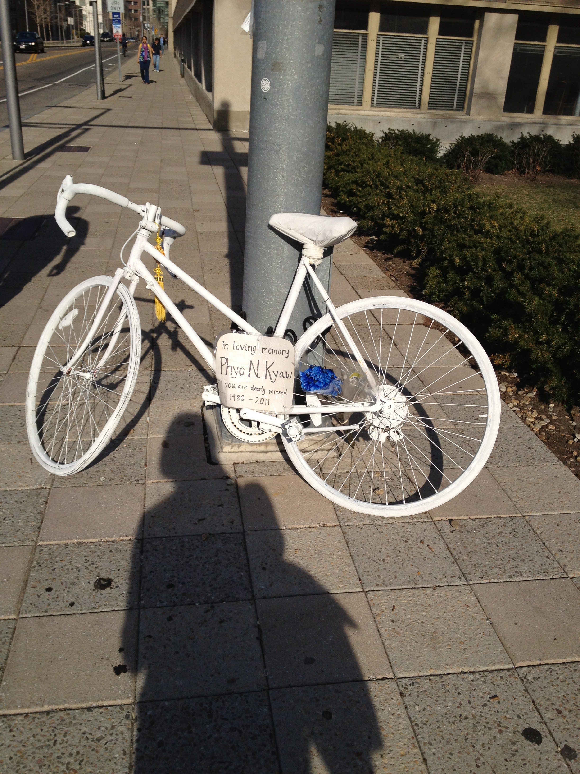

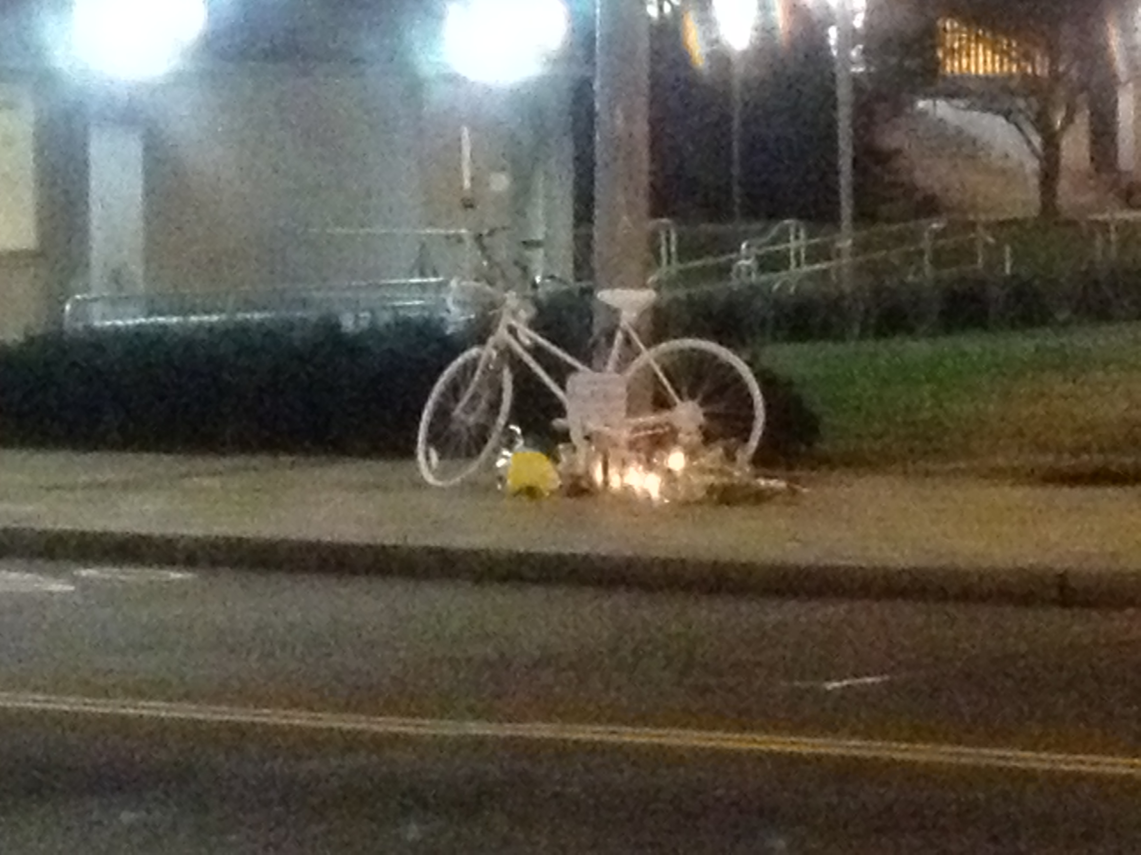

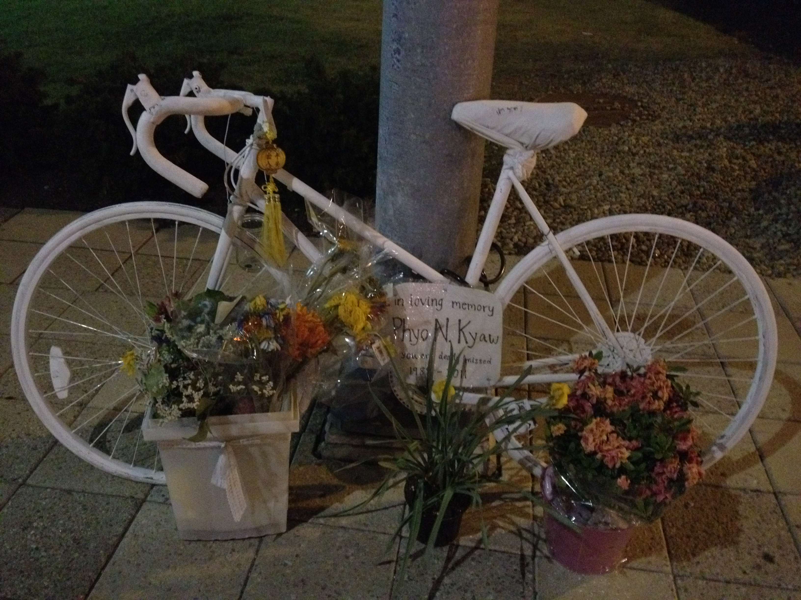

Text:

Phyo was an avid cyclist and was active in cycling groups around Boston. He stressed safety in bicycling, so it came as a shock to all when we heard the [news of Phyo’s fatal bike accident](http://tech.mit.edu/V131/N59/kyaw.html). Wandering along Massachusetts Avenue and Vassar Street, you might have seen the ghost bike that Phyo’s co-worker, Andrea, set up in his memory. Thank you to those who have taken the time and care to replace the flowers with fresh ones from time to time.

We send lots of gratitude to MIT for allowing us to keep this bike there in memory of Phyo. Special thanks to Norman M. from MIT facilities for taking care of this bike and locking it up inside during harsh Boston winter storms!

We are looking at ways of promoting bike safety with MIT Campus Police, MIT Health Services, MIT Transportation Office, etc. By retelling Phyo’s story and making more students aware of bicycling in Cambridge/Boston, we can look after each others’ safety!

Other relevant news links:

* **Reporting of accident:**

[Friends mourn death of bicyclist in Cambridge](http://www.wickedlocal.com/cambridge/news/x352570264/Friends-mourn-death-of-bicyclist-in-Cambridge)

[Brief one-line report (see the comments on people's take of the tanker turning & safety)](http://www.universalhub.com/2011/bicyclist-dies-collision-18-wheeler-cambridge)

* **Dangerous Intersections - Mass Ave & Vassar**

Cyclists beware (!) of [the most dangerous intersections in Cambridge](http://www.wickedlocal.com/cambridge/features/x1080707370/The-most-dangerous-intersections-in-Cambridge#axzz1iPevrRFD).

* **Tanker Truck Route map**

Cambridge Truck Routes and Restrictions:

In case you are wondering, there are certainly routes and restrictions for tanker trucks around Cambridge. Here is a [PDF map](http://www.cambridgema.gov/CityOfCambridge_Content/documents/Routes&Restrictions.pdf) and here is an [online description](http://www2.cambridgema.gov/traffic/trucks.cfm) from the City of Cambridge of these routes and restrictions.

* **Other:**

[MIT Obituary following April Memorial Service 2012](http://tech.mit.edu/V132/N19/kyaw.html)

Take Action!

Do you want to make cycling safer in Cambridge? Are you an EMT? Are you part of the Cycling Team? Does your word hold weight when it comes to promoting safety at MIT? (MIT Police, Transportation Office?) We would love to hear from you, especially if you are interested in helping us create partnerships across organisations around Cambridge, Boston, and MIT to organize an event for this upcoming or next year’s MIT Orientation that would teach incoming students about what it is like to bike in Cambridge/Boston. We would like to inform students of tricky intersections and dangerous streets, and hopefully even familiarize them with the streets of Cambridge via bike tours, as well as their rights and responsibilities as bicyclists.

Other links to share or ways in which you would like to help make cycling safer in Cambridge? Please shoot us an email at [pnnkfoundation@gmail.com](mailto:pnnkfoundation@gmail.com) or visit our Contact Us page (link to Contact Us section) to fill out the form and we will get back to you.